Exp 23: VMware Workstation — Create a Virtual Hard Disk & Allocate Storage

Aim
Add and provision an additional virtual hard disk to an existing VMware VM.
Procedure
- Shut down the VM → right-click VM → Settings.
- Add… → Hard Disk → choose SCSI/SATA/NVMe controller as desired.
- Select Create a new virtual disk → enter size (e.g., 10–50 GB).
- Choose Store as a single file (faster) or Split (portable) → Finish.
- Power on the VM; in the guest OS, open Disk Management (Windows) or lsblk/fdisk (Linux).
- Initialize → Partition → Format the new disk (NTFS/ext4) and assign a drive letter/mount point.
Output
Figure 1 Virtual Machine with 1 CPU, 2 GB RAM, and 15 GB storage
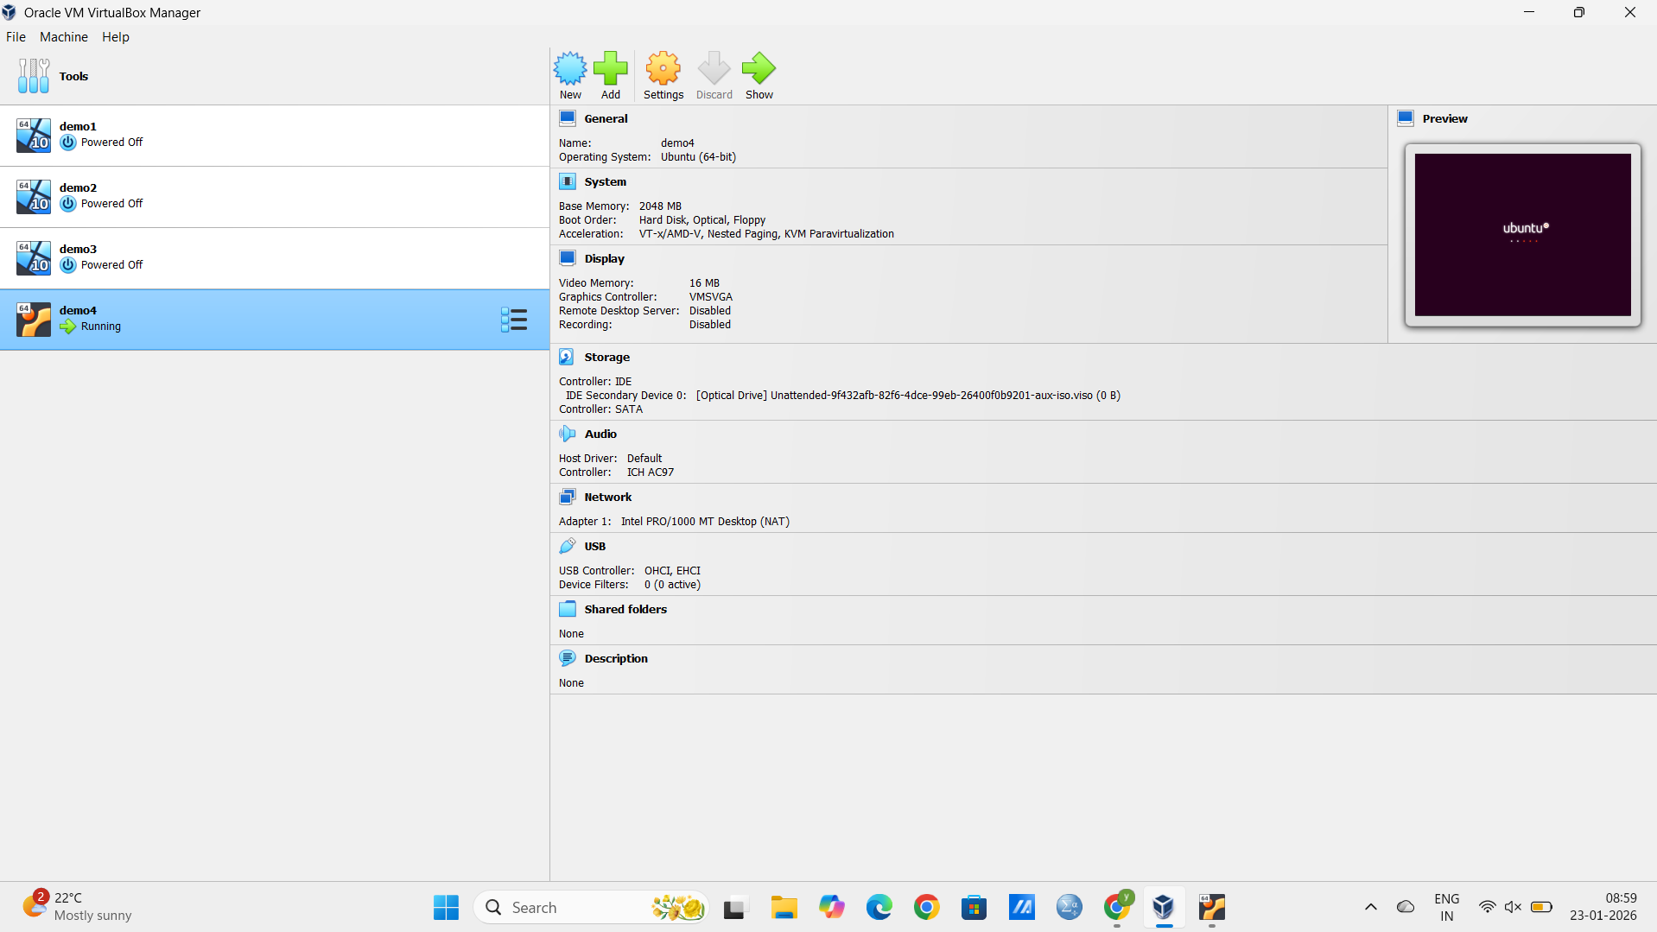
Result
A new, usable virtual disk appears inside the guest OS with allocated, formatted storage ready for files.

